

COLLEGE OF BUSINESS AND ECONOMICS

SCHOOL OF BUSINESS

DEPERTMENT OF BUSINESS INFORMATION TECHNOLOGY

BIT LEVEL TWO

WEB TECHNOLOGY

PROJECT NAME: ONLINE STRESS MANAGEMNT WORKSHOPS PLATFORM

|  |  |
| --- | --- |
| NAME | REG NUMBER |
| MUKAMANA Clementine | 222013529 |

SUBMITTED TO: Dr BUGINGO Emmanuel

DATE: 23/05/2024

**ONLINE STRESS MANAGEMNT WORKSHOPS PLATFORM**

The Online Stress Management Workshops Platform" is a digital platform designed to provide a comprehensive suite of resources, tools, and interactive workshops to help individuals effectively manage and alleviate stress in their lives.

**MISSION OF ONLINE STRESS MANAGEMNT WORKSHOPS PLATFORM**

The mission of the Online Stress Management Workshops Platform is to empower individuals with the knowledge, skills, and support necessary to effectively manage and alleviate stress in their lives. Through a comprehensive suite of resources, interactive workshops, and community engagement, we strive to promote mental well-being, resilience, and a sense of empowerment among our users. Our platform aims to provide accessible and evidence-based solutions for stress management, fostering a supportive environment where individuals can learn, grow, and thrive.

**THE VALUES OF ONLINE STRESS MANAGEMNT WORKSHOPS PLATFORM**

1.Empowerment: We believe in empowering individuals to take control of their mental well-being by providing them with the knowledge, skills, and resources needed to effectively manage stress.

2. Accessibility: We are committed to ensuring that our platform is accessible to individuals from diverse backgrounds and demographics, regardless of their geographical location, socioeconomic status, or ability.

3. Evidence-based: Our approach to stress management is grounded in evidence-based practices and techniques supported by research and clinical expertise, ensuring the effectiveness and reliability of our offerings.

4. Community: We value the importance of community support in promoting mental health and resilience. Our platform fosters a sense of belonging and connection among users, encouraging peer support, collaboration, and mutual encouragement.

5. Continuous Improvement: We are committed to ongoing learning and improvement, regularly updating our content, features, and services based on user feedback, emerging research, and industry best practices to ensure the highest quality of care and support

6. Privacy and Confidentiality: We prioritize the privacy and confidentiality of our users' data, implementing robust security measures and adhering to strict data protection standards to safeguard their information and ensure their trust and confidence in our platform.

WHY CHOOSE ONLINE STRESS MANAGEMNT WORKSHOPS PLATFORM

because the Online Stress Management Workshops Platform offers a comprehensive, accessible, and supportive environment for individuals seeking effective strategies to manage and alleviate stress in their lives

1. **DATABASE DESIGN**

INTRODUCTION

In this database we will be describing database of the system tables inside that database and the way those tables were created in, addition on that in this chapter we will show table views from original tables, the relationship between created tables that are in this database.

In database of this system be ready to look at operation used on some table in this database so that you can know what to and what not to do on given entity.

Develop this system database there are some material which were used so that we can get on final output . Among these the important one is xampp saver MySQL, so now let together navigate this database system.

**1.ENTITIES**

Description of all entities and their corresponding attributes that are in this data base database

**1.users table database structure**



**2.attendences table database structure**

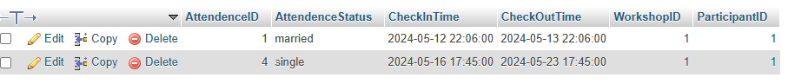

**3.**  **certificates table database structure**



**4.enrollment table database structure**

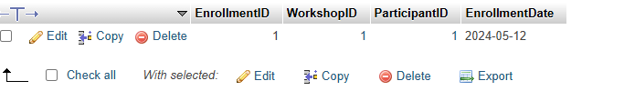

**5.feedback table database structure** This table to contain all payment and will be created by system admin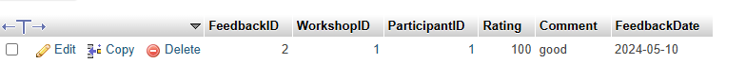

**6.instructors table database structure**

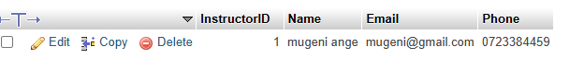

**7.participants table database structure**



**7.resources table database structure**



**8.session table database structure**



**9.topics table database structure**

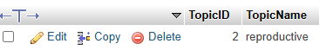

**10.** **workshops table database structure**



**2.LOGICAL DATABASE MODEL**

The figure below describes how table related to one another logically in this system. What to say about this graph is that foreign key and primary one will generate these relationship as shown on this logical database model as well as entity relationship diagram below that

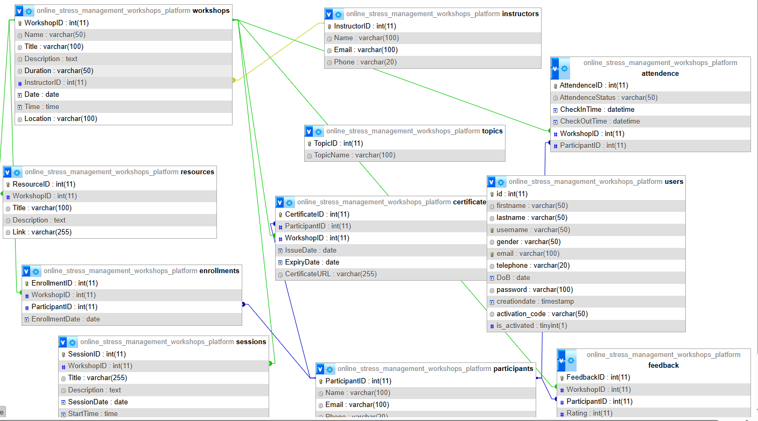

**4.SQL**

In this sql we will be describing techniques especially SQL queries used to create, delete tables as well as inserting and deleting data in the tables in that database.

1.create database is `online_stress_management_workshops_platform `;

2.queries to create tables and their relationship

create tables

CREATE TABLE `attendence` (

`AttendenceID` int(11) NOT NULL,

`AttendenceStatus` varchar(50) DEFAULT NULL,

`CheckInTime` datetime DEFAULT NULL,

`CheckOutTime` datetime DEFAULT NULL,

`WorkshopID` int(11) DEFAULT NULL,

`ParticipantID` int(11) DEFAULT NULL

) ;

CREATE TABLE `certificates` (

`CertificateID` int(11) NOT NULL,

`ParticipantID` int(11) DEFAULT NULL,

`WorkshopID` int(11) DEFAULT NULL,

`IssueDate` date DEFAULT NULL,

`ExpiryDate` date DEFAULT NULL,

`CertificateURL` varchar(255) DEFAULT NULL

);

CREATE TABLE `enrollments` (

`EnrollmentID` int(11) NOT NULL,

`WorkshopID` int(11) DEFAULT NULL,

`ParticipantID` int(11) DEFAULT NULL,

`EnrollmentDate` date DEFAULT NULL

) ;

CREATE TABLE `feedback` (

`FeedbackID` int(11) NOT NULL,

`WorkshopID` int(11) DEFAULT NULL,

`ParticipantID` int(11) DEFAULT NULL,

`Rating` int(11) DEFAULT NULL,

`Comment` text DEFAULT NULL,

`FeedbackDate` date DEFAULT NULL

);

CREATE TABLE `instructors` (

`InstructorID` int(11) NOT NULL,

`Name` varchar(100) DEFAULT NULL,

`Email` varchar(100) DEFAULT NULL,

`Phone` varchar(20) DEFAULT NULL

) ;

CREATE TABLE `participants` (

`ParticipantID` int(11) NOT NULL,

`Name` varchar(100) DEFAULT NULL,

`Email` varchar(100) DEFAULT NULL,

`Phone` varchar(20) DEFAULT NULL

) ;

CREATE TABLE `resources` (

`ResourceID` int(11) NOT NULL,

`WorkshopID` int(11) DEFAULT NULL,

`Title` varchar(100) DEFAULT NULL,

`Description` text DEFAULT NULL,

`Link` varchar(255) DEFAULT NULL

) ;

CREATE TABLE `sessions` (

`SessionID` int(11) NOT NULL,

`WorkshopID` int(11) DEFAULT NULL,

`Title` varchar(255) DEFAULT NULL,

`Description` text DEFAULT NULL,

`SessionDate` date DEFAULT NULL,

`StartTime` time DEFAULT NULL,

`EndTime` time DEFAULT NULL

) ;

CREATE TABLE `topics` (

`TopicID` int(11) NOT NULL,

`TopicName` varchar(100) DEFAULT NULL

) ;

CREATE TABLE `users` (

`id` int(11) NOT NULL,

`firstname` varchar(50) DEFAULT NULL,

`lastname` varchar(50) DEFAULT NULL,

`username` varchar(50) DEFAULT NULL,

`gender` varchar (50) DEFAULT NULL,

`email` varchar(100) DEFAULT NULL,

`telephone` varchar(20) DEFAULT NULL,

`DoB` date DEFAULT NULL,

`password` varchar(100) DEFAULT NULL,

`creationdate` timestamp NOT NULL DEFAULT current_timestamp(),

`activation_code` varchar(50) DEFAULT NULL,

`is_activated` tinyint(1) DEFAULT 0

);

CREATE TABLE `workshops` (

`WorkshopID` int(11) NOT NULL,

`Name` varchar(50) DEFAULT NULL,

`Title` varchar(100) DEFAULT NULL,

`Description` text DEFAULT NULL,

`Duration` varchar(50) DEFAULT NULL,

`InstructorID` int(11) DEFAULT NULL,

`Date` date DEFAULT NULL,

`Time` time DEFAULT NULL,

`Location` varchar(100) DEFAULT NULL

);

**4. queries to display all information in created tables**

SELECT * FROM `attendences`

SELECT * FROM `certificate `

SELECT * FROM `enrollment `

SELECT * FROM `workshops`

SELECT * FROM `instructors`

SELECT * FROM `participants`

SELECT * FROM `sessions`

SELECT * FROM `feedback`

SELECT * FROM `topics`

SELECT * FROM `resources`

**5. queries to update table in online_stress_management_workshops_platform database**

UPDATE `topics` SET `TopicName`='single' WHERE ` TopicID`='1';

Conclusion: A database is a structured collection of data that is organized in a way that makes it easy to manage, access, and update. It typically consists of tables (entities) that store data, with each table containing rows (records) and columns (fields/attributes). Databases are used in various applications and industries to store and manage data efficiently.

this database we have achieved more on this system using MySQL and the system in terms of keeping data is working well with different operation we have settled on it in some tables like revoking some activities, triggers are created in this database and relationship of much of these tables in this database are there to link them one by one. So this will lead us to creating the link between data store which is database and the final user of the system which will be focusing more on user interface and connectivity**.**

**2.web technology**

**1 .introduction**

In this chapter I will be describing how powerful general purpose was used to create the analyzed web. Under this chapter I will undergo full detail of how everything will function together with database that have been describe above and how it cope with full analyzed system.

**Tools used to develop this system in web technology:**

**1.xammp**

**2.text editor(sublime)**

**Forms description**

So let look together how the system will function one by one from the beginning up to the end.

**1.Registration form**

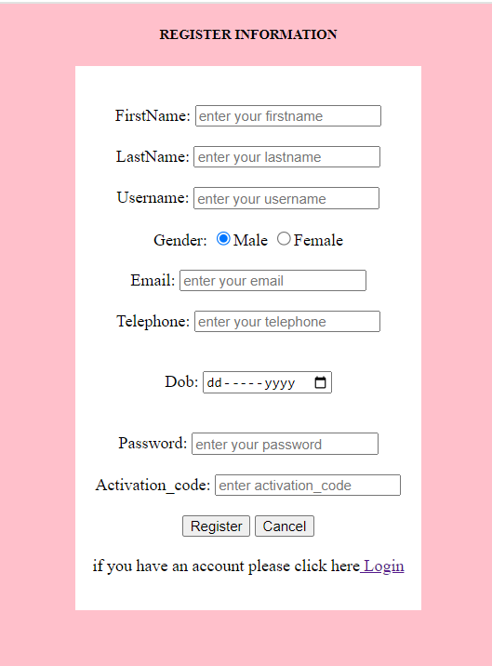

**2)Login form (online_stress_management_workshops_platform):**

Login form for the user when the user have username or email and password login in this page when the user don’t have email and password click button create account this the first page of the system where system will choose destination depending on the function he/she possess in the wesite

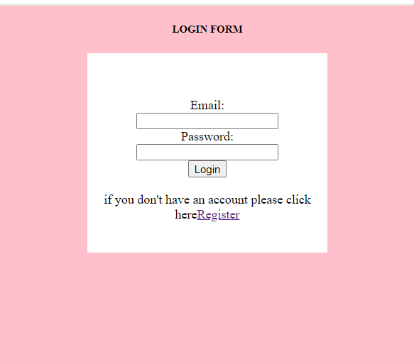

**3)INDEX**



**4.MENU OR HOME PAGE**

With this page we will be informed what tasks can system administrator do in this system like adding who cannot access the system or who do not have knowledge to use the system. Adding new topic, adding new system order or generating new instructors of the participants will be the part to focus on home page



**5) attendences information form**

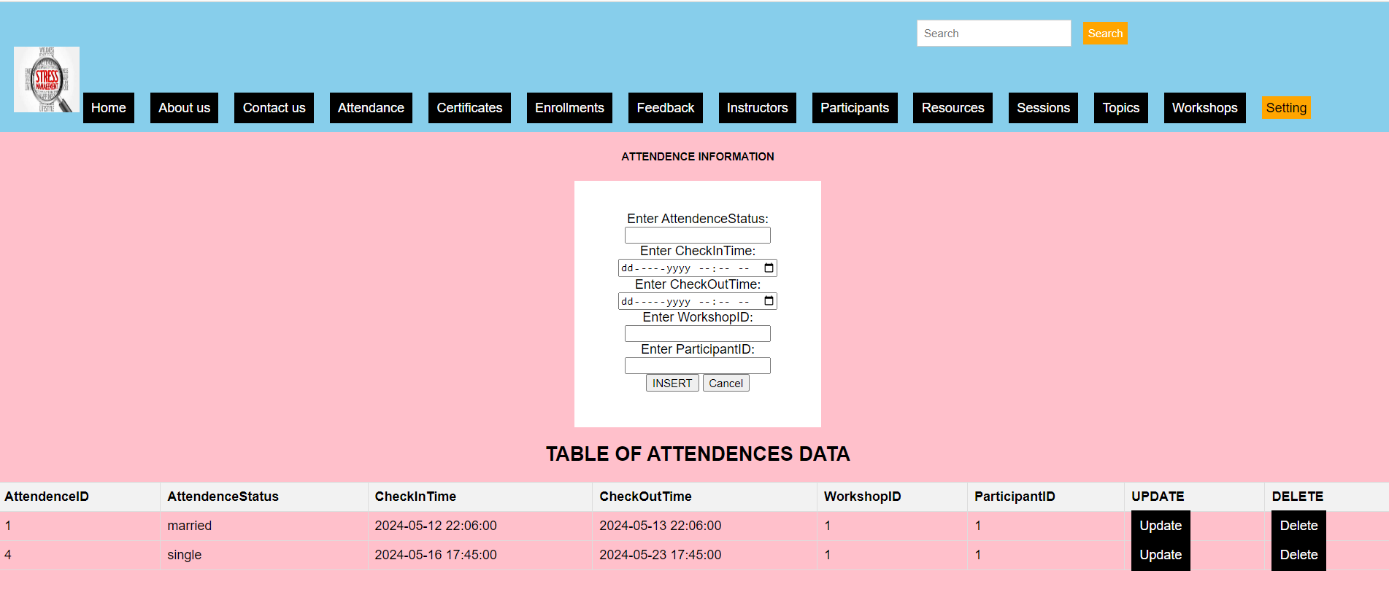

**6) certificate information form**

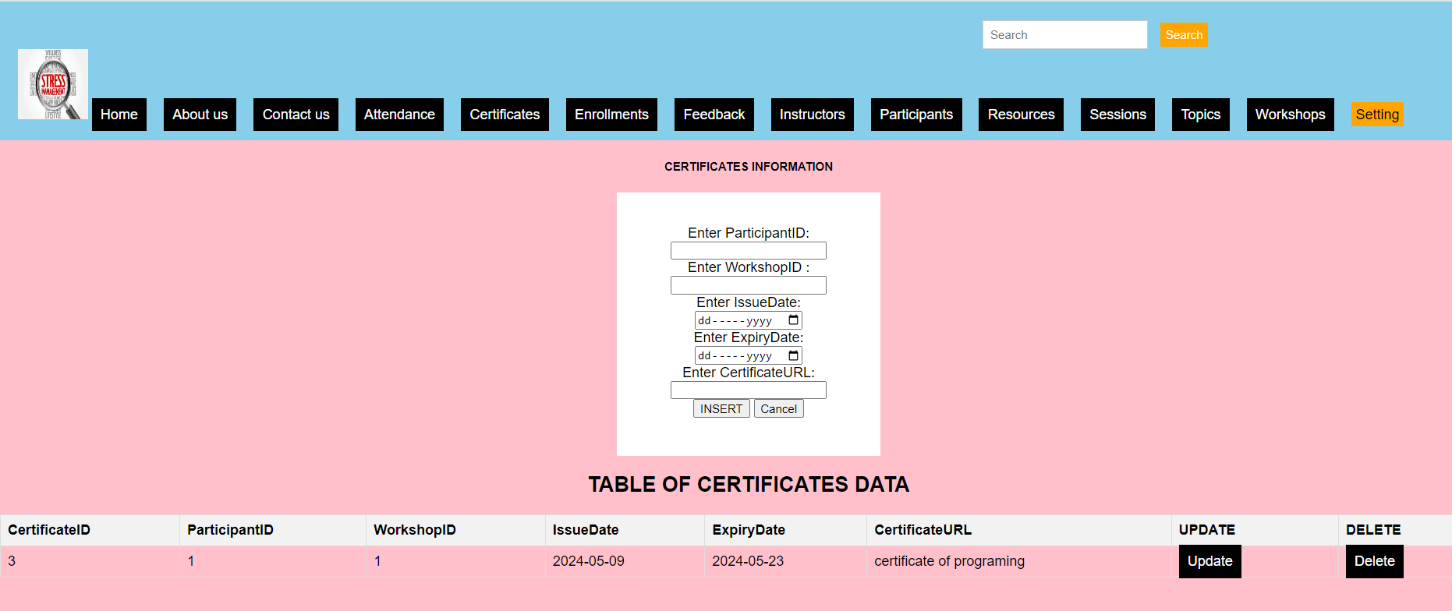

**7) enrollment information form**

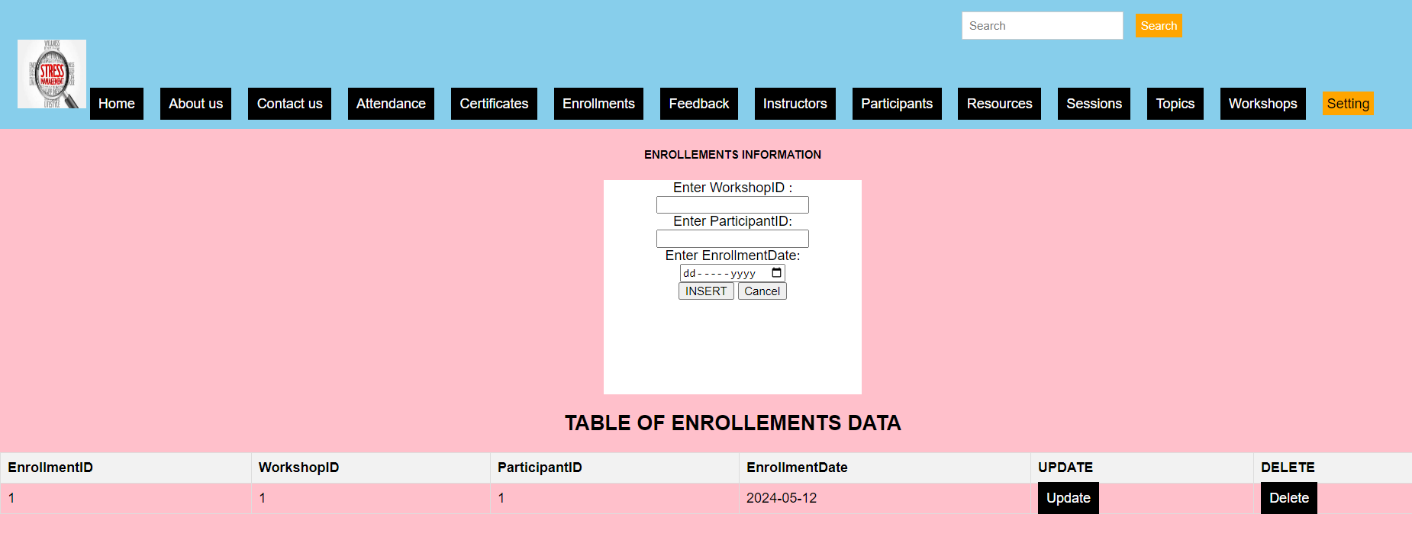

**8)feedback information form**

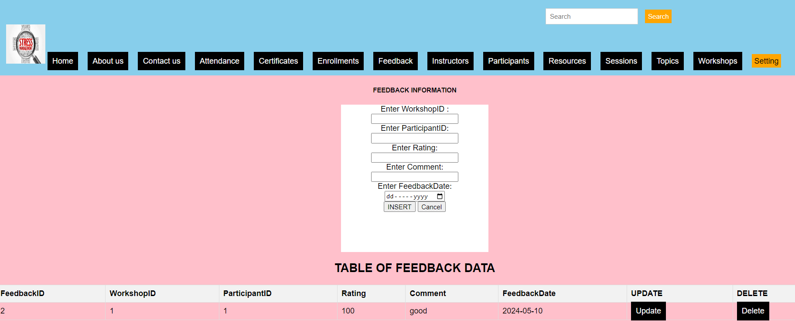

**9)instructors information form**

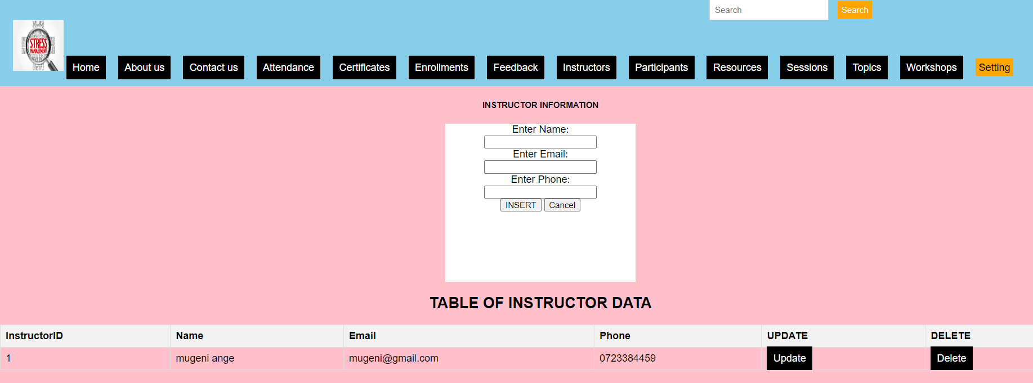

**10)participants information form**

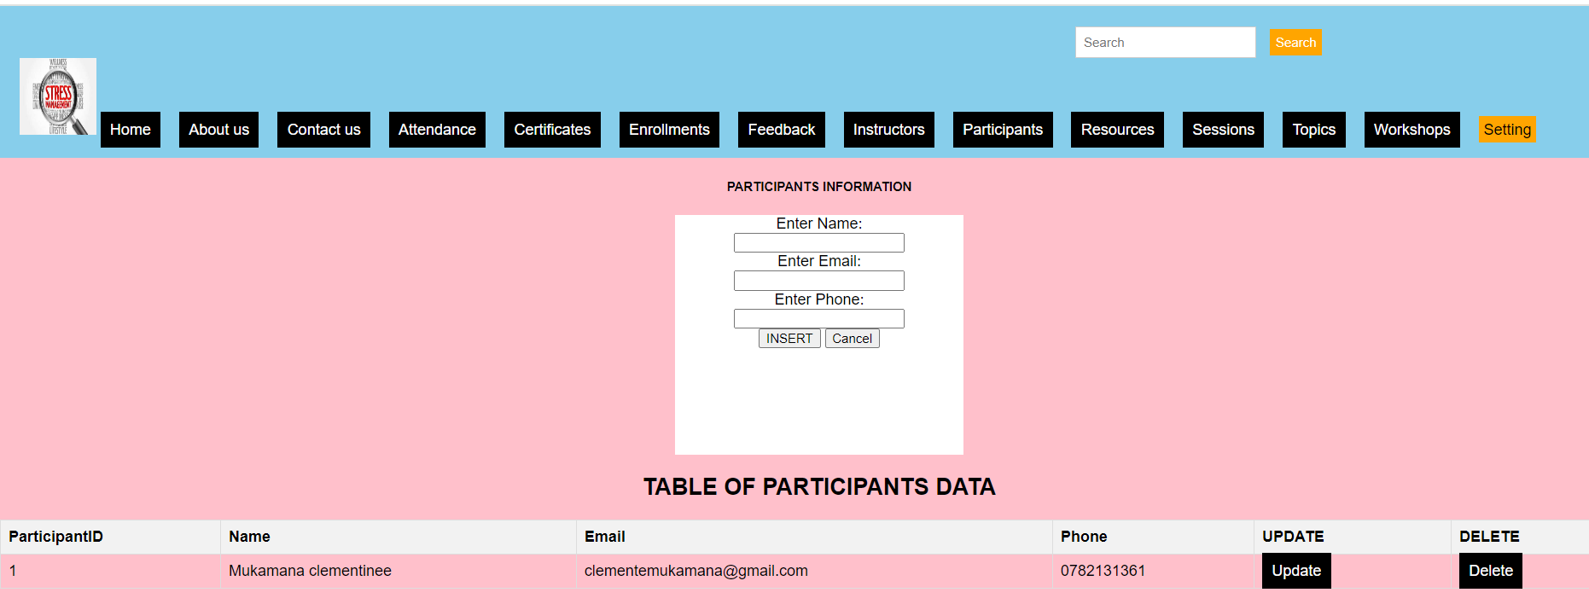

**11)resources information form**

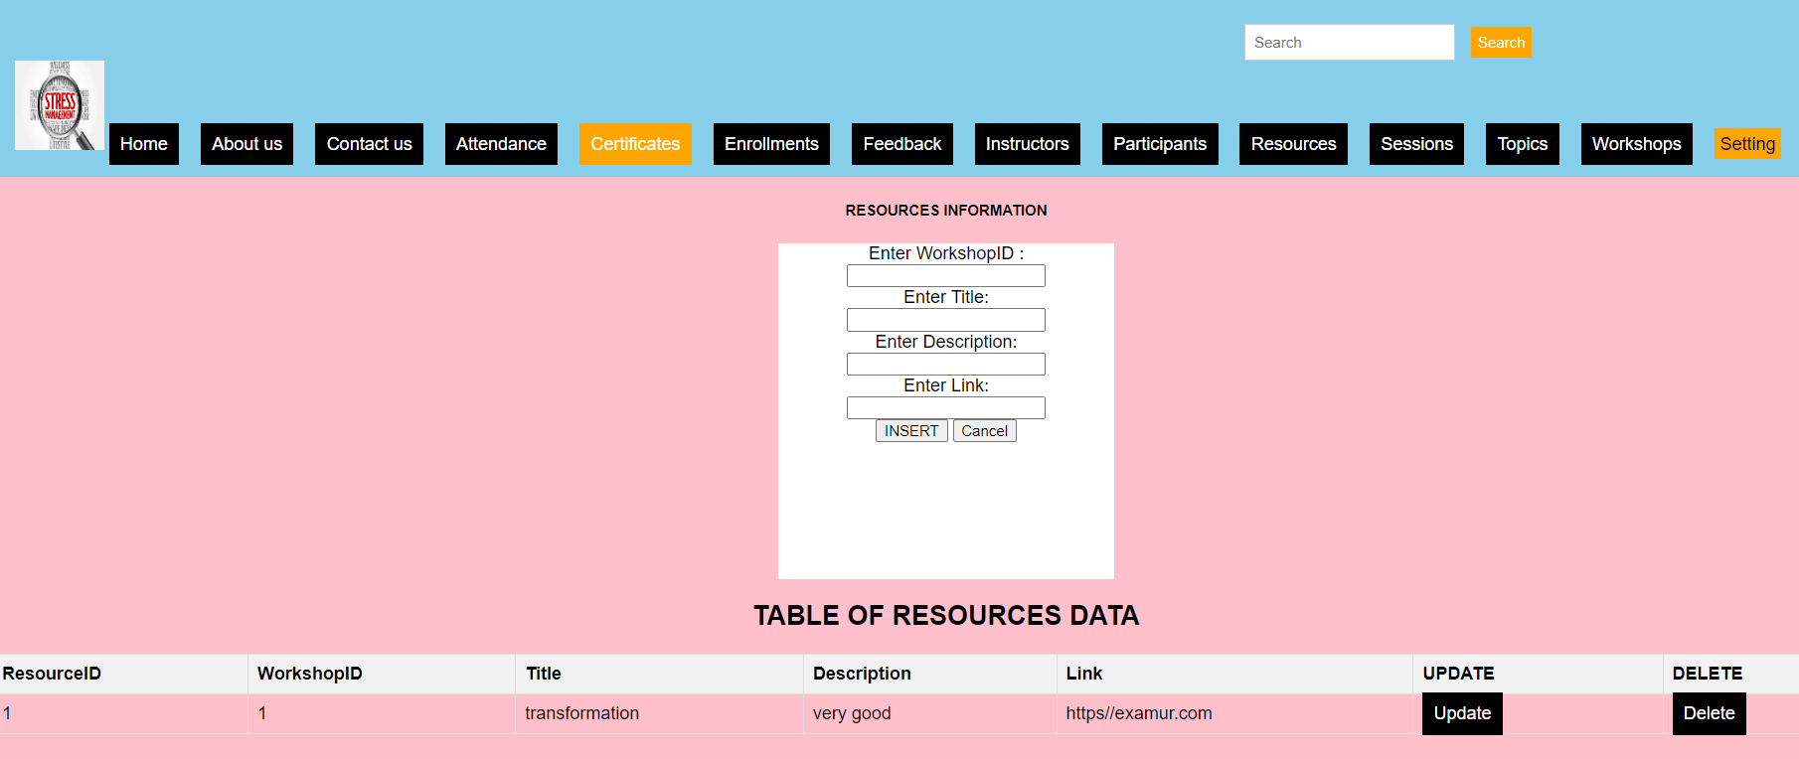

**12)Session information form**

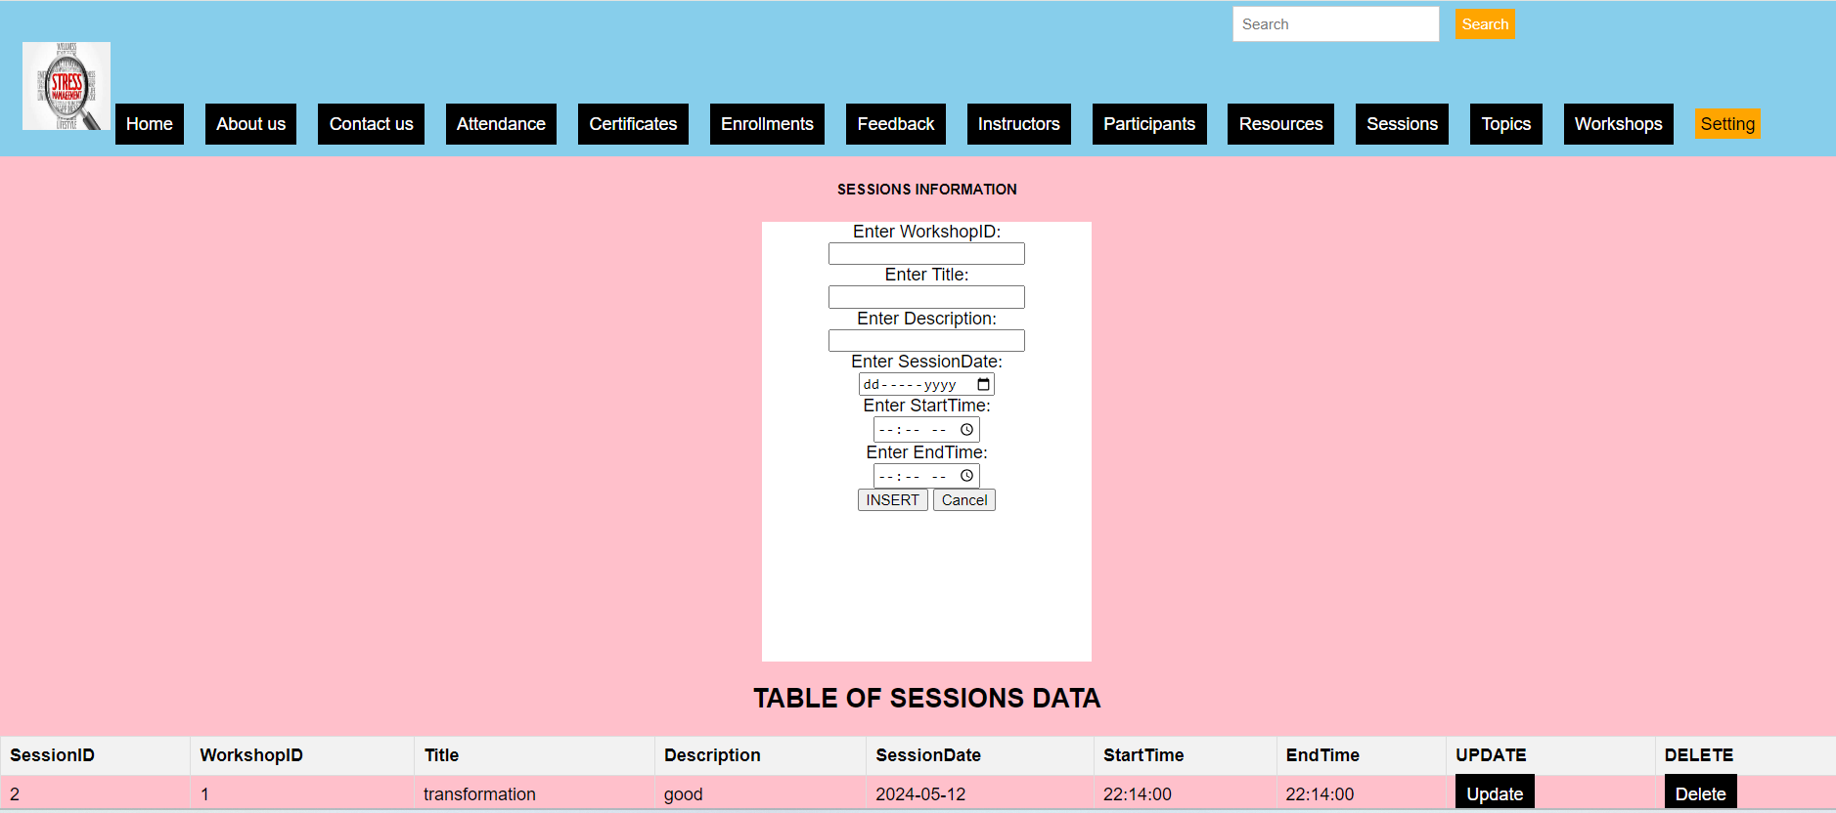

**13)Topic information form**

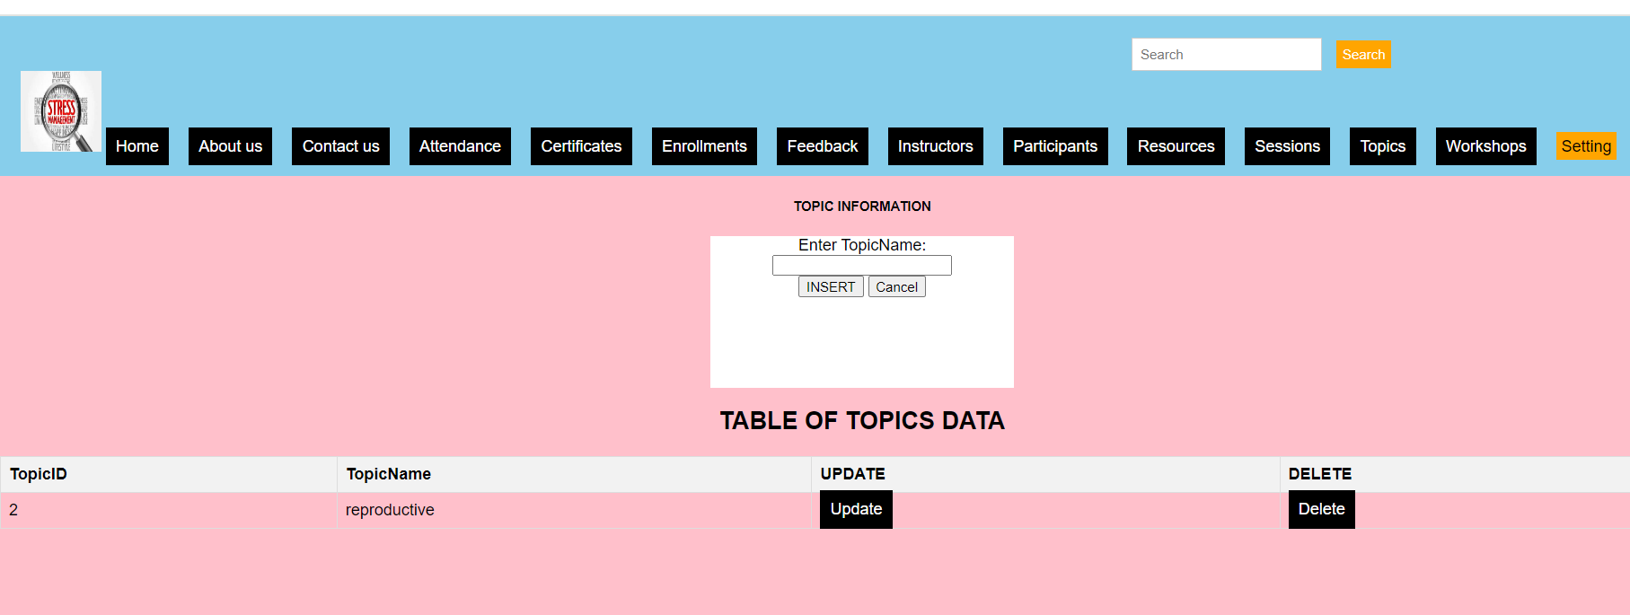

**14)Workshops information form**

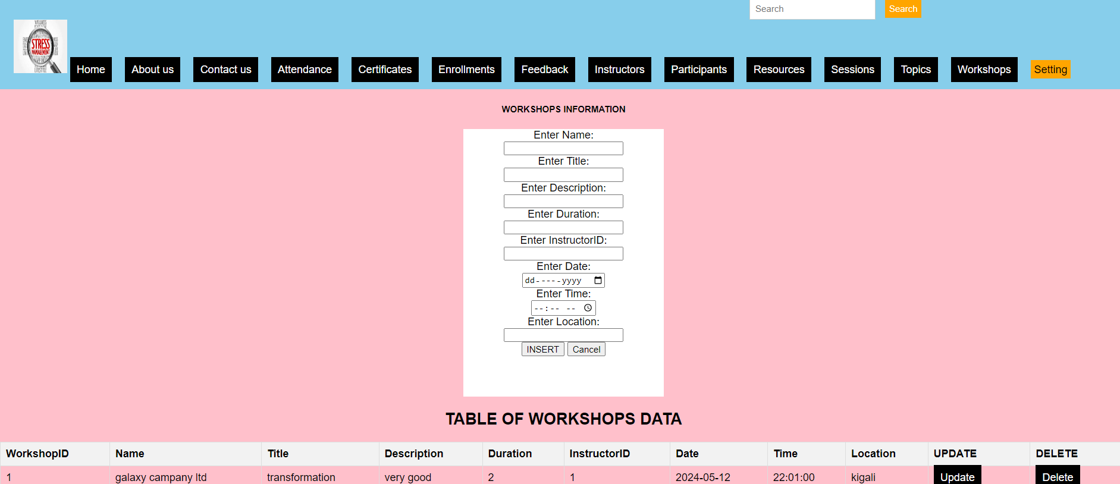

**Conclusion:**

By concluding this web technology ­­­especially in my developed system, we can say that I have final product that I was expecting to have it, the manipulation of data is going well the design is there with special appearance, but there much to go on and that need to be improved will be gained from external view apart from system developer